***ArcadESP: The Open-Source Retro Gaming Handheld***

**Description:**

The circuit is centered on an ESP32-WROVER-I microcontroller. The main power supply for the system is 3.3V.

The design integrates several key peripherals for operation. It includes a TFT screen for graphics display, managed through multiple GPIO connections of the microcontroller. For user input, the system features a series of buttons, including direction controls (up, down, left, right), action buttons (Start, Select, A, B), and menu buttons, which connect to a PCF8574 I/O port expander.

Data storage is handled through a MicroSD card slot with push-out functionality, allowing the reading and writing of information. Additionally, the circuit incorporates an auto-reset section for the microcontroller. Test points (TP1, TP2, TP3, TP4) are also included for monitoring key voltages such as V_USB, V_BATT and 3.3V.

**Resources:**

|  |  |
| --- | --- |
| [USB-B](https://lcsc.com/datasheet/lcsc_datasheet_2110151630_XKB-Connection-U-E-M1SS-Y-1_C319151.pdf) | Power and data connector. |
| [LTC4054](https://lcsc.com/datasheet/lcsc_datasheet_2409272231_NATLINEAR-LN2054Y42AMR_C141406.pdf) | Integrated circuit for battery charging. |
| [MIC5219 3.3v Regulator](https://lcsc.com/datasheet/lcsc_datasheet_2410121904_MICROCHIP-MIC5219-3-3YM5-TR_C29613.pdf) | Regulates and stabilizes the voltage to 3.3V. |
| [ESP32 WROVER-I](https://lcsc.com/datasheet/lcsc_datasheet_2411121102_ESPRESSIF-ESP32-WROVER-IE-N8R8_C701351.pdf) | The main microcontroller (the brain). |
| [CH340](https://lcsc.com/datasheet/lcsc_datasheet_2506051505_WCH-CH340G_C14267.pdf) | USB to serial converter for programming. |
| [BUTTONS](https://lcsc.com/datasheet/lcsc_datasheet_2304140030_XKB-Connection-TS-1187A-C-C-B_C318889.pdf) | Buttons for user interaction. |
| [PCF8574 I/O Expander](https://lcsc.com/datasheet/lcsc_datasheet_2504101957_HGSEMI-PCF8574T-TR_C2987288.pdf) | Expands input/output pins for the buttons. |
| [TFT Display](https://cdn-shop.adafruit.com/datasheets/ILI9341.pdf) | Screen for visual output. |
| [Micro SD Card](https://lcsc.com/datasheet/lcsc_datasheet_1811082127_Korean-Hroparts-Elec-TF-01A_C91145.pdf) | Module for external storage. |
| [Audio DAC UDA1334ATS](https://www.nxp.com/docs/en/data-sheet/UDA1334ATS.pdf) | Converts digital audio to analog. |
| [Amplifier PAM8403](https://lcsc.com/datasheet/lcsc_datasheet_2208041800_Slkor-SLKORMICRO-Elec--PAM8403_C5122557.pdf) | Amplifies the audio signal for output. |
| [Jack 3.5mm](https://lcsc.com/datasheet/lcsc_datasheet_2409271733_Korean-Hroparts-Elec-PJ-611-5A_C128983.pdf) | Output connector for headphones or speakers. |
| [LED Blue](https://lcsc.com/datasheet/lcsc_datasheet_2507101606_Hubei-KENTO-Elec-KT-0603B_C2288.pdf) | Visual status indicator light. |

**Features:**

Processing Core: ESP32-WROVER-I module with a dual-core CPU, Wi-Fi, Bluetooth, and integrated PSRAM.

Connectivity & Power: USB-B port for power and programming via an onboard CH340 USB-to-UART controller.

Power Management: Includes an LTC4054 Li-Ion battery charger and an MIC5219 LDO regulator for a stable 3.3V supply.

Audio Subsystem: Features an I2S Stereo DAC (UDA1334ATS), a PAM8403 Class-D amplifier, and a 3.5mm audio jack output.

User Interface: TFT color display for visual output, accompanied by user input buttons and a status LED.

External Storage: Micro SD card slot for expandable data and media storage.

I/O Expansion: PCF8574 I/O expander to provide additional digital pins over the I2C bus.

**Applications:**

* Retro Emulation Console (Main Application)
* Portable Media Player
* IoT Device and Control Tool
* Development and Learning Platform (All in One)

**Power Tree:**

▶ Power Source (USB / Battery)

└───▶ Power Systems & Protections

│

├───▶ Charging Circuit (e.g., TP4056)

│ │

│ ├───> Charges the Li-Po Battery (3.7V)

│ │

│ └───> Status LEDs (Charging / Full)

│

└───▶ 3.3V Voltage Regulator

│

└───▶ Main Power Rail (3.3V)

│

├─▶ B. Processing & Storage

│ ├─ Microcontroller (ESP32)

│ └─ Storage (MicroSD Slot)

│

├─▶ C. Output (Display & Audio)

│ ├─ Display (TFT)

│ └─ Audio Output (DAC / Amp)

│

├─▶ D. Inputs & Controls

│ ├─ I/O Expander (I2C)

│ └─ Auto-Reset Circuit

└─▶ E. Debug & Programming

└─ USB to UART Interface

**Input Source:** Power originates from either a USB connection or a Li-Po Battery.

**Charging & Protection:** This input power feeds a charging circuit, which manages battery charging and provides a regulated output. This stage also powers the status LEDs.

**Main Regulation:** Power from the battery or charging circuit is routed to the 3.3V Voltage Regulator. This is the core of the power system, converting the variable battery voltage (typically 3.0V-4.2V) into a stable, constant 3.3V.

**Distribution:** The 3.3V rail distributes power to all active modules in the device: the microcontroller, display, audio circuitry, SD card slot, I/O expander, and the programming interface.

**Power Budget:**

The system can be powered by a **USB** connection or a **Li-Po battery**. The input power goes through a protection and charging circuit. A central **3.3V voltage regulator** then takes this power and supplies a stable 3.3v to all the main components. These components include the **ESP32 microcontroller**, the **TFT display**, the **audio output**, the **MicroSD slot**, and the input/control circuits.

**Typical Use:** The device draws **423 mA (2.12 W)** from the 5V USB source for normal operation.

**Maximum Use:** Under heavy load (like using Wi-Fi), the draw spikes to **1.11 A (5.55 W)** from the 5V USB source.

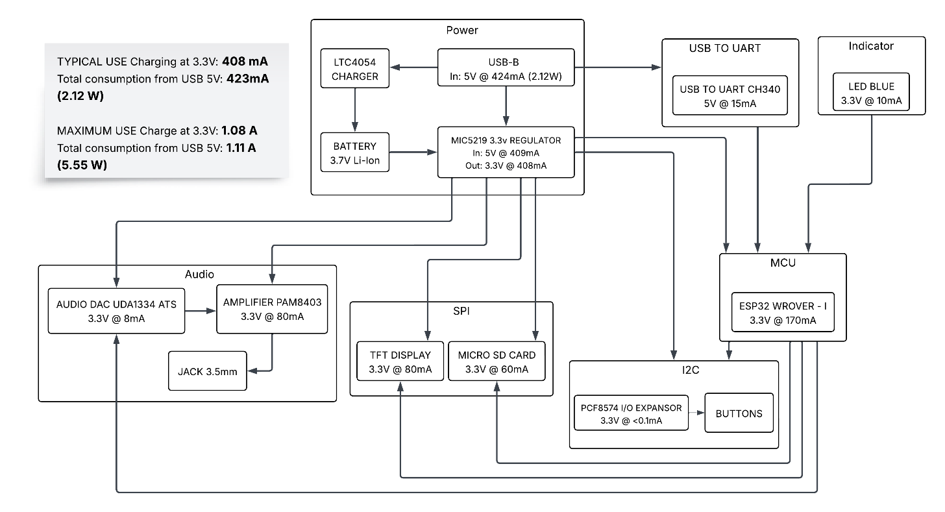

**Block Diagram:**

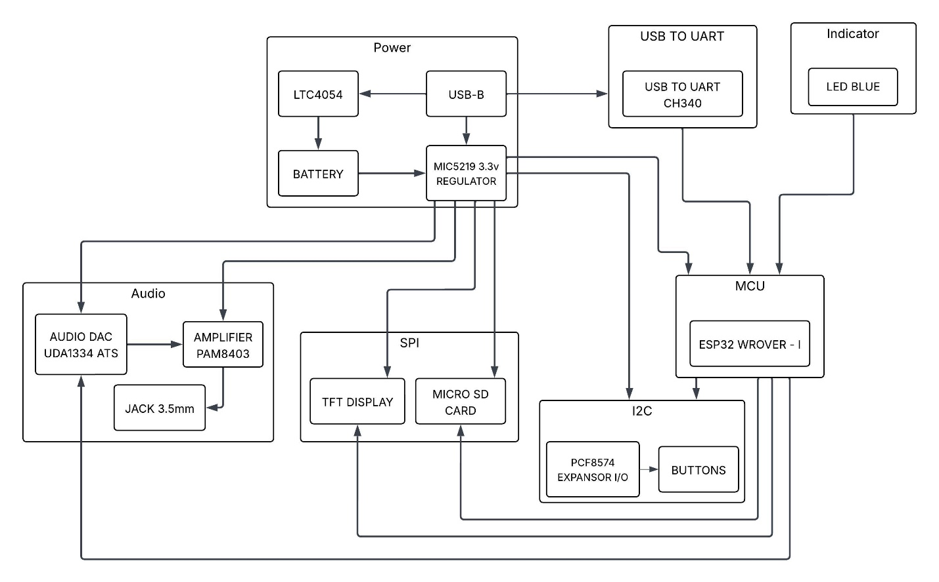

**3D Model:**

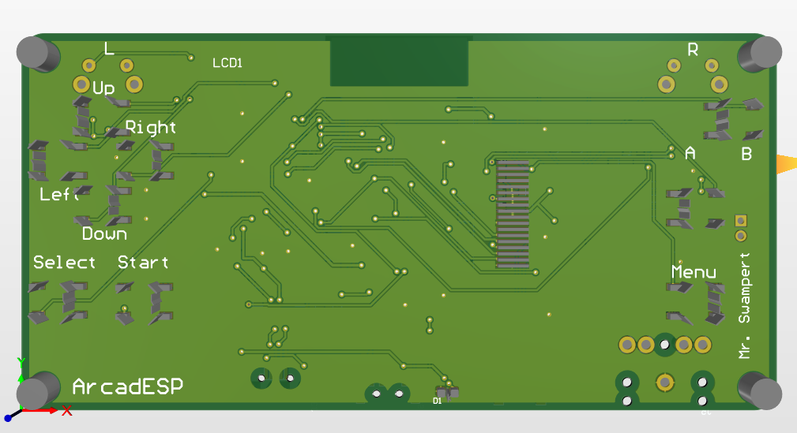

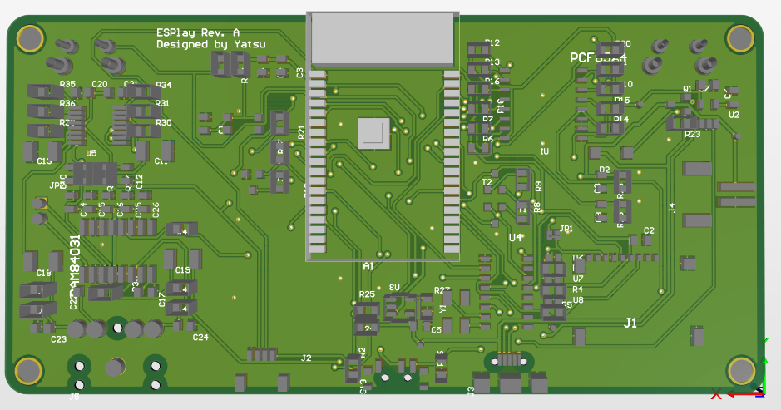

**Temperature:**

|  |  |  |  |
| --- | --- | --- | --- |
| **Component** | **Category** | **Operating Temperature Range** | **Additional Notes** |
| LTC4054 | Battery Charger | 0°C to 70°C (Guaranteed Performance) | The operating range extends from -40°C to 85°C. It has a thermal protection feature that reduces charging current if the internal temperature exceeds 120°C. |
| MIC5219 | Voltage Regulator | -40°C to 125°C | This 3.3V regulator has a wide operating range, suitable for various environmental conditions. |
| ESP32 WROVER-I | MCU | -40°C to 85°C | Most ESP32-WROVER models operate in this range, making them robust for embedded applications. |
| PAM8403 | Audio Amplifier | -40°C to 85°C | Includes over-temperature protection that shuts down the device if the internal temperature reaches 140°C. |
| CH340 | USB to UART | -40°C to 85°C | This is the standard range for most variants of this converter chip. |
| PCF8574 | I/O Expander | -40°C to 85°C | This component for input/output port expansion operates in a standard industrial range. |
| UDA1334A | Audio DAC | -20°C to 85°C | The digital-to-analog audio converter has a slightly more restricted operating range at the lower end compared to other components. |
| TFT Display | Display | Generally, 0°C to 50°C (Typical) | Exact ranges can vary depending on the manufacturer, but this is a common range for consumer TFT displays. Operation outside this range can affect visibility and lifespan. |
| Micro SD Card | Storage | -25°C to 85°C (Typical for Industrial Grade) | Consumer-grade cards may have a more limited range (e.g., 0°C to 70°C). The exact range depends on the specification of the card used. |
| Blue LED | Indicator | -40°C to 85°C (Typical) | Light-emitting diodes (LEDs) typically have a very wide operating range. |

**References:**

Pebri, “GitHub - pebri86/esplay_micro_hardware: Micro version of esplay hardware, ESP32 based gaming console,” *GitHub*. <https://github.com/pebri86/esplay_micro_hardware>

“ESPLay Micro V2,” *Handheld ESP32 Game Console | Makerfabs*. <https://www.makerfabs.com/esplay-micro-v2.html>

**Link to the repository where the files are hosted:**

<https://github.com/MrSwampert/Portable-Gaming-Console-with-ESP32>